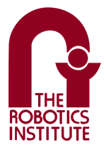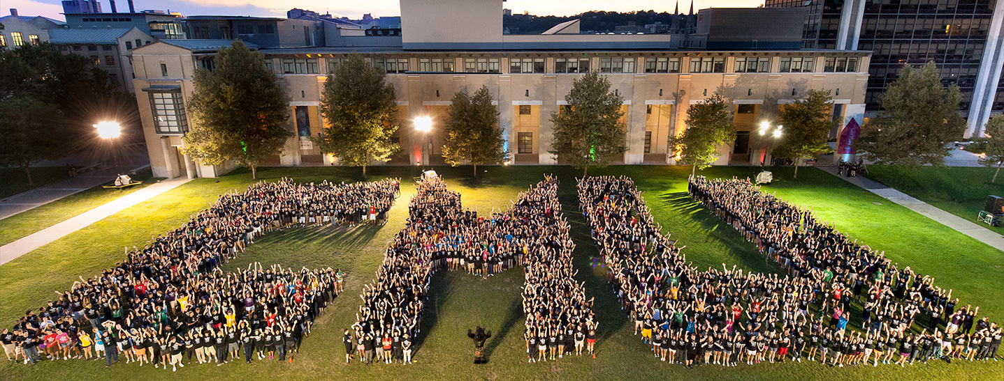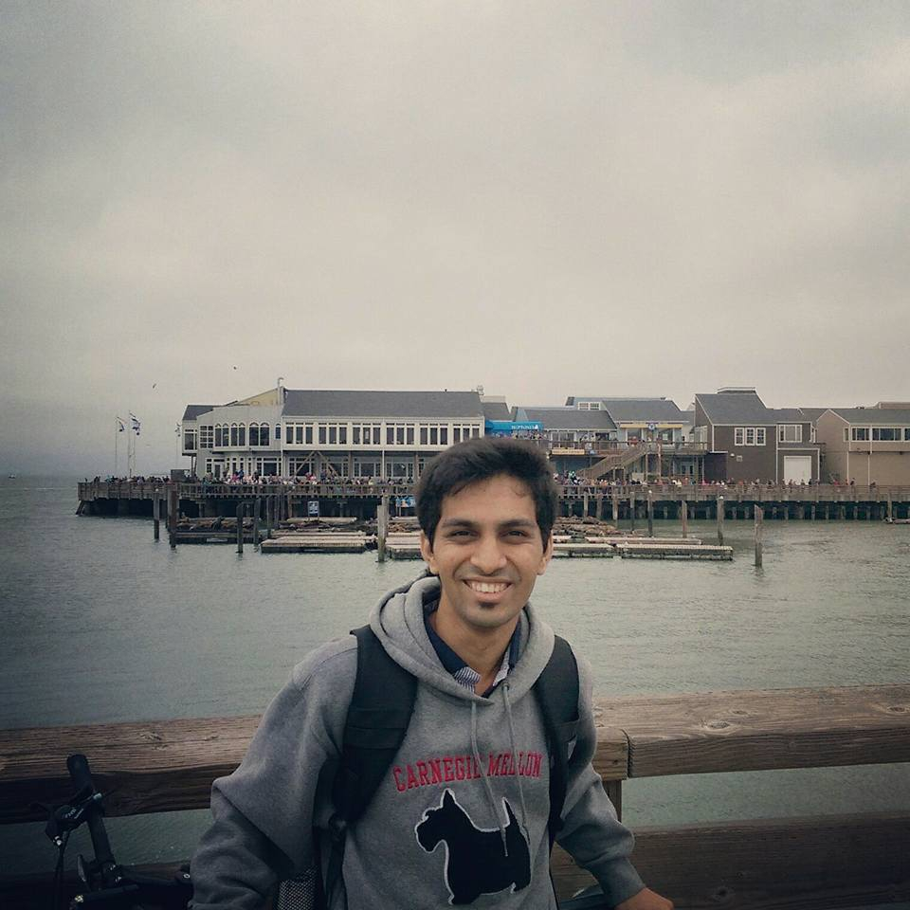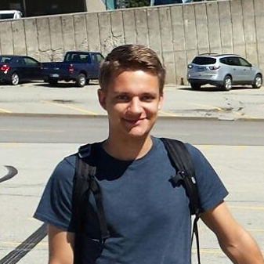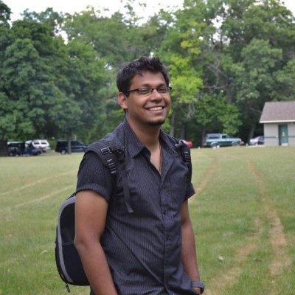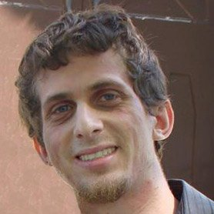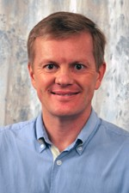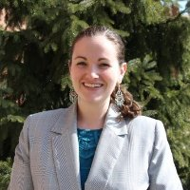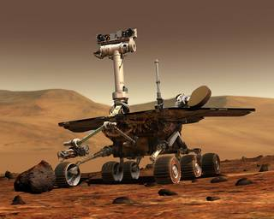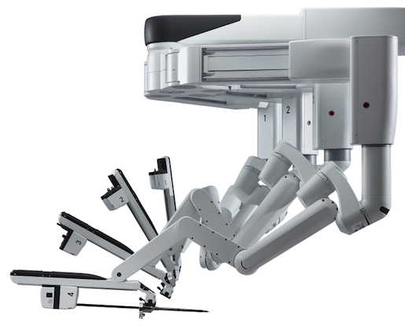

Notes from Dr. Dolan and Sarah

Relevant Links

6

Creating New Chapters

First Year Overview

*Hello World!*

Newsletter, January 2017

The primary goal of the alumni association is to help us alums to stay in touch with each other. The Alumni Association will be organizing events and issuing a quarterly newsletter to help you catch up and find out which interesting problems and projects alums are working on.

In addition, the Alumni Association aims to promote collaborative learning where we all get an insider’s view on the on the progress made in different robotic sectors through first-hand accounts, both by alums and by others working at the forefront of robotics. We will interview pioneers of robotics both in the academic and non-academic world and ask them about, in the big picture, what problem statement they are trying to solve and the value proposition they are trying to bring to the society.

Finally, the Alumni Association will keep you informed of employment opportunities.

Introduction

Welcome to the first newsletter of the MRSD Alumni Association! In this newsletter you can read more about the motivation behind having an alumni association, how the association is structured, and what you can expect from it in 2017.

Motivation

4

5

Contents

3

**Treasurer and Acting Historian Silicon Valley Chapter**  
**C*lass of 2015***

Hi all, I graduated in 2015 as well and am currently working at Apple. As a treasurer and an acting Historian for the Silicon Valley chapter, I will be assisting Allard and Arpit in financing and managing events in & around the Bay Area. You can always reach out to me via LinkedIn/Facebook. Bay Area alums, we are quite excited for making a stronger MRSD network in the Valley. Let’s make this happen!

Jaineel Dalal

**Communications Manager**  
**C*lass of 2012***

I graduated from the First Batch aka ‘Trail Blazers’ by Hagen. I am currently working in Intuitive Surgical Inc. as a Systems Analyst (Robotics Controls Engineer). Besides robotics, I like sports, outdoors and am fond of art and music. You can reach me at [comms.mrsdaa@gmail.com](mailto:comms.mrsdaa@gmail.com) or connect on any social networking site. Cheers!

I am also serving as the Silicon Valley Chapter President. So Bay Area folks, do not hesitate to get in touch for matters related to Silicon Valley Chapter!

**Treasurer**  
**C*lass of 2015***

Hi Everyone! I graduated in 2015 and I currently work at Uber’s Advanced Technologies Group in Pittsburgh as a Perception engineer. I am the treasurer of the Alumni Association and my main concern for this year is guiding the financing of the Alumni Association events. Don’t hesitate to reach out to me at [treasurer.mrsdaa@gmail.com](mailto:treasurer.mrsdaa@gmail.com) if you have any questions regarding this and always feel free to hook me up on LinkedIn!

Allard Dupuis

**Director**  
**C*lass of 2015***

Jeffrey is the Director of the MRSD Alumni Association and the President of its Pittsburgh chapter. He founded the MRSDAA along with Arpit and Allard because he was amazed by the camaraderie that developed in his class and he wants to see that camaraderie continue to deepen among all MRSD alums. Professionally, Jeffrey specializes in electrical hardware and embedded software. He currently works for Discovery Robotics.

Arpit Mittal

Jeffrey Blum

# The Team

I want first to thank Jeffrey and the team of volunteers he has assembled for their willingness to form and nurture an MRSD alumni organization. I see it as a great way to sustain the remarkable esprit de corps which each class of MRSD students establishes while you are on campus. Secondly, I want to congratulate each of you on the great work you have been doing since graduation. The program's reputation continues to grow, as evidenced by its recognition by Grad School Hub this past summer as the top robotics engineering program and the continued enthusiasm of robotics industry employers for its graduates. Finally, I look forward to closer ties among the MRSD alumni and CMU through the efforts of the alumni organization. It would be great, for example, to have MRSD alumni return and give talks to the current MRSD students, and I am looking into providing annual funding for that. Any ideas along these and similar lines are welcome. Keep us posted on how you are doing and make sure to visit if you are in Pittsburgh!

Best regards,

# Staff Notes

Prof. John Dolan

Sarah Conte

Hello Alumni,

Thank you for the warm welcome to the MRSD Family! A handful of you have contacted me since early August, when I began in the role of Academic Program Manager, to say hello and express how the MRSD program has impacted you personally and professionally. The Robotics Institute has also impacted me over the past four months. The current students are extremely hard-working individuals, each optimizing his or her unique skills and forging a path to contribute to our global society. I am fortunate to witness all that they accomplish, and it is clear that the MRSD students before them set a precedent for such innovation and inspiration. I am thankful for your role in that, and I hope you will continue to embody the values of Carnegie Mellon in your life after graduate school. MRSD is gaining acclaim, and your support is appreciated as we embark upon another successful year.

What can you expect from the Alumni Association in 2017?

|  |  |
| --- | --- |
| * **Reunion** | The main event is the reunion, which will take place at Carnegie Mellon at the end of May. This is a great opportunity to meet and catch up with your fellow alums living in other parts of the country and the world. The reunion also coincides with the final MRSD project poster presentations by the current class. If you are interested in the projects they have been working on, make sure to attend! An email with more detailed information and a link to RSVP will be sent out early next year. We will also need some volunteers, so if you would like to help out, let us know! |
| * **Your chapter** | A key part of the Alumni Association is your local chapter. Your chapter is the best way to stay in touch with other alums living in your area. Every year each chapter will organize at least two local events. These events can range from attending a conference to going to a sports game. It’s completely up to the chapter to decide. The chapters rely on their members to help out, so if you have any ideas for events or would like to get involved, don’t hesitate to reach out to your chapter’s president and see how you can contribute. Your chapter and the newsletter will provide you with more information on upcoming events as they get closer. |
| * **Newsletter** | You’re reading it right now! The newsletter is one of the best ways to keep track of what is going on in the world of robotics, important things happening at the Robotics Institute and the MRSD program, and how your fellow alums are doing. The newsletter is issued quarterly. If you have cool ideas for newsletter articles, important life events to announce to fellow alums, or other content you’d like to share, please reach out to Arpit Mittal, the Communications Manager, at [comms.mrsdaa@gmail.com](mailto:comms.mrsdaa@gmail.com). |

First Year Overview

The MRSD Alumni Association was founded with two chapters representing the two largest geographic concentrations of MRSD alumni, Pittsburgh and Silicon Valley. But the truth is there are MRSD alumni everywhere, so we have developed a process for creating new chapters. Why create new chapters? The simplest reason is funding; any money we have will be distributed to the chapters, so becoming a chapter potentially means you can host bigger events. You also get the benefit of outreach in that every time a class graduates, chapter presidents will be notified of emerging alumni that will be moving to their area.

So how exactly do you create a new chapter? Well, the process is quite simple. First, you must have at least five members in one defined geographic area. It can be a city, a state, a region, anything. You must also select your initial officers: President, Treasurer, and Historian (for an explanation of the different officer positions, please contact the MRSDAA Director). Once you have all of the appropriate information, email it to the MRSDAA Director at [director.mrsdaa@gmail.com](mailto:director.mrsdaa@gmail.com) and your petition will be considered. If your petition is accepted, your chapter will immediately become part of the MRSDAA. From that point on, the only requirement is that you hold one event in the year your chapter was created, and two events per year after that. It’s really that simple.

To reiterate, the three things you must email to [director.mrsdaa@gmail.com](mailto:director.mrsdaa@gmail.com) if you want to form a new chapter are:

1. Description of the geographic area your chapter will cover
2. Membership list with at least 5 names
3. Names of initial officers

That’s it! If you are interested in forming a chapter but aren’t sure if there’s enough alums near you, feel free to reach out and we can help you get started.

Creating New Chapters

* Coming up a Youtube channel link, which will host videos of all the projects so far!
* [MRSD website](http://mrsd.ri.cmu.edu/)
* [MRSD projects](http://mrsd.ri.cmu.edu/project-examples/)

If you would like to join the Alumni Association and haven’t signed up yet, fill out the [sign-up](https://docs.google.com/forms/d/e/1FAIpQLScuK_zpylka71UOIzPNqb3TMzuLrjtKgvbjX4ic-HSJsTzhbA/viewform) form. Signing up should not take more than a minute and is completely free. Within a day after submitting you will receive an email confirming your membership.

**►**[**Sign up**](https://docs.google.com/forms/d/e/1FAIpQLScuK_zpylka71UOIzPNqb3TMzuLrjtKgvbjX4ic-HSJsTzhbA/viewform)

Other

Signing up

Links